import cv2

import matplotlib

import matplotlib.pyplot as plt

import numpy as np

from google.colab.patches import cv2_imshow

img = cv2.imread('road.jpg',cv2.IMREAD_COLOR)

# Display original image

cv2_imshow(img)

# Convert to graycsale

img_gray = cv2.cvtColor(img, cv2.COLOR_BGR2GRAY)

edges = cv2.Canny(img_gray, 50,200) # Canny Edge Detection

cv2_imshow(edges)

#Detect points that form a line

lines=cv2.HoughLinesP(edges,1,np.pi/100,55,minLineLength=10,maxLineGap=250)

#Draw lines on the image

for line in lines:

  x1,y1,x2,y2=line[0]

  cv2.line(img,(x1,y1),(x2,y2),(255,0,0),3)

#Result Image

cv2_imshow(img)

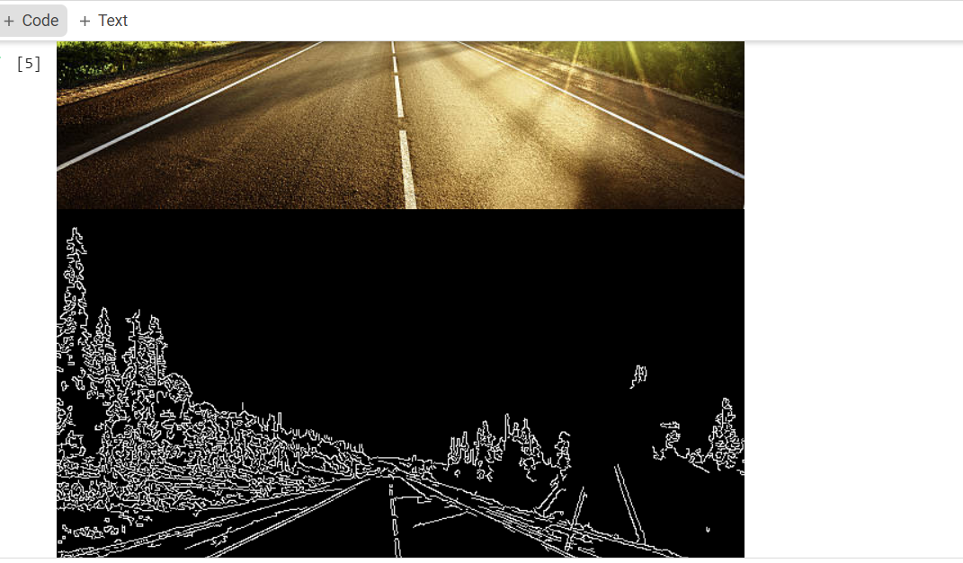

#Hue circle

img = cv2.imread('eyes.jfif', cv2.IMREAD_COLOR)

#Convert to grayscale

gray = cv2.cvtColor(img, cv2.COLOR_BGR2GRAY)

#Blur using 3 * 3 kernel

gray_blurred = cv2.blur(gray, (3,3))

#Apply Hough transform on the blurred image

detected_circles = cv2.HoughCircles(gray_blurred,

                    cv2.HOUGH_GRADIENT, 1, 20, param1 = 50,

                    param2 = 30, minRadius = 1, maxRadius = 40)

#Draw the circles that are detected.

if detected_circles is not None:

  #Convert the circle parameters a, b and r to integers.

  detected_circles = np.uint16(np.around(detected_circles))

  for pt in detected_circles[0, :]:

    a, b, r = pt[0], pt[1], pt[2]

    #Draw the circumference of the circle.

    cv2.circle(img, (a,b), r, (0, 255, 0), 2)

    #Draw a small circle (of radius 1) to show the center.

    cv2.circle(img, (a,b), 1, (0,0, 255), 3)

    cv2_imshow(img)

    cv2.waitKey(0)

import cv2

import numpy as np

img = cv2.imread('chess.jpg')

#original image

cv2_imshow(img)

gray=cv2.cvtColor(img,cv2.COLOR_BGR2GRAY)

gray=np.float32(gray)

dst=cv2.cornerHarris(gray,2,3,0.04)

#result is dilated for marking the corners, not important

dst=cv2.dilate(dst,None)

#Threshold for an optimal value, it may vary depending on the image

img[dst>0.01*dst.max()]=[0,0,255]

#dilated image

cv2_imshow(dst)

#corner detection output

cv2_imshow(img)

import cv2

import numpy as np

img = cv2.imread('road.jpg')

#original image

cv2_imshow(img)

gray=cv2.cvtColor(img,cv2.COLOR_BGR2GRAY)

gray=np.float32(gray)

dst=cv2.cornerHarris(gray,2,3,0.04)

#result is dilated for marking the corners, not important

dst=cv2.dilate(dst,None)

#Threshold for an optimal value, it may vary depending on the image

img[dst>0.01*dst.max()]=[0,0,255]

#dilated image

cv2_imshow(dst)

#corner detection output

cv2_imshow(img)

nemo=cv2.imread('nemo.jfif')

plt.imshow(nemo)

plt.show()

nemo_rgb=cv2.cvtColor(nemo,cv2.COLOR_BGR2RGB)

plt.imshow(nemo_rgb)

plt.show()

hsv_nemo=cv2.cvtColor(nemo_rgb,cv2.COLOR_RGB2HSV)

plt.imshow(hsv_nemo)

plt.show()

#color segmentation

import cv2

import numpy as np

import matplotlib.pyplot as plt

from google.colab.patches import cv2_imshow

from matplotlib.colors import hsv_to_rgb

%matplotlib inline

#for orange color segmentation

light_orange=(1,190,200)

dark_orange=(18,255,255)

lo_square=np.full((10,10,3),light_orange,dtype=np.uint8)/255.0

do_square=np.full((10,10,3),dark_orange,dtype=np.uint8)/255.0

plt.subplot(1,2,1)

plt.imshow(hsv_to_rgb(do_square))

plt.subplot(1,2,2)

plt.imshow(hsv_to_rgb(lo_square))

plt.show()

mask=cv2.inRange(hsv_nemo,light_orange,dark_orange)

result=cv2.bitwise_and(nemo,nemo,mask=mask)

plt.subplot(1,2,1)

mask = cv2.inRange(hsv_nemo,light_orange,dark_orange)

result = cv2.bitwise_and(nemo,nemo,mask=mask)

plt.subplot(1,2,1)

plt.imshow(mask,cmap="gray")

plt.subplot(1,2,2)

plt.imshow(result)

plt.show()

